Manual Billing Verification for K8s Apps
volkman@
2018-08-06

Overview
This document describes the process of manually verifying billing integration for commercial Kubernetes apps to be listed in GCP Marketplace.

Base assumptions
This document assumes that the partner's application exists in the Marketplace (possibly restricted), that its metering integration is working, and that Google-managed service and billing config are set up and active.

Process

Enable billing export to BigQuery
The final step of this process is to examine billing data in a billing export. Prior to doing that, we must ensure that billing data for the project and account being used is actually exported somewhere.

First, check to see whether billing export is already enabled for your billing account. If you're using a shared account (such as Marketplace Testing), there's a chance someone else has already enabled it. In that case, you may need to get access to the existing BigQuery dataset, or change the export destination.

To check whether export is enabled:
- Navigate to the linked account for the project you're planning to deploy into.
- Click the Billing export link in the left nav.
- Look for the "Enabled" status:
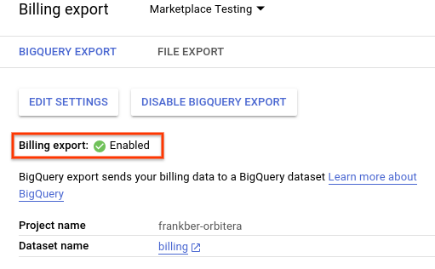
If export is enabled, and you have access to the dataset, skip to the next section. Otherwise, follow the remaining steps to enable it.

- Open the BigQuery UI and select the project that you want to use for billing export (can be the same project you'll use for deployments).
- Click your project's name under the Resources section on the left.
https://pantheon.corp.google.com/bigquery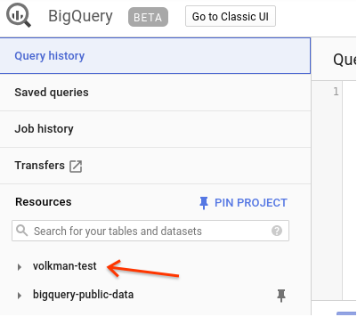

- Click Create dataset on the right side of the screen.
- Give your dataset a descriptive name (such as "billing"), and accept the other defaults.
- Navigate back to the linked billing account page.
- Click the Billing export link in the left nav.
- Click Edit settings.
- Select the project containing the newly-created dataset, and select the new dataset.
- Click Save.

Deploy the application
- Browse to the application's details page in GCP Marketplace.
- Create a plan (if necessary).
- Configure and launch the application.
  - Take note of the application name that you used when deploying.

Get the consumer project ID
Later on we'll query for billing data using the consumer project ID generated during entitlement creation. The easiest way to get this ID is by reading the reporting secret created during application deployment. Assuming kubectl is configured to talk to the cluster you just deployed to, use the following commands:

$ export APP_NAME=<the app name you used when deploying>
$ kubectl get secret "$APP_NAME-reporting-secret" --output json | jq -r '.["data"]["consumer-id"]' | base64 -d | cut -d: -f2

The output will be a project ID that begins with "pr". For example, "pr13ce6cac8d44a2b5". Store this ID away for later.

Generate usage data
The exact specifics of this step vary based on the application. Some applications bill purely based on time usage, in which case all you need to do is let the application run. Others bill based on events or storage, in which case you'll need to know how to perform billable usage and do so with the deployed application.

Extract exported data
After waiting for the billing pipeline to process usage data, we'll pull relevant data from BigQuery to a sheet for further examination. Note that it can take ~6 hours for usage data to show up in the export.

- Open the BigQuery UI and select the project that you used for billing export.
- Click your project's name under the Resources section on the left, as before.
- There should be a newly-created in the dataset that you created whose name starts with "gcp_billing_export_v1". Record the name of this table.
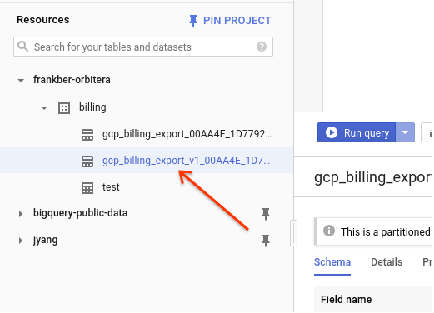
- Copy the following query into the query editor, replacing these placeholders with the values that you've recorded:
<dataset> | The BigQuery dataset used for billing export.
<table> | The BigQuery table created by billing export.
<consumer-project> | The project ID retrieved from the apps reporting secret Kubernetes resource.

SELECT
service.id AS service_id,
service.description AS service_description,
sku.id AS sku_id,
sku.description AS sku_description,
usage_start_time,
usage_end_time,
project.id AS project_id,
project.name AS project_name,
export_time,
cost,
currency,
usage.amount AS usage_amount,
usage.unit AS usage_unit,
usage.amount_in_pricing_units AS usage_amount_in_pricing_units,
usage.pricing_unit AS usage_pricing_unit,
invoice.month AS invoice_month
FROM <dataset>.<table>
WHERE project.id = '<consumer-project>' ORDER BY usage_start_time ASC;

- Click Run query and wait for the query to finish.
- Export the results to a sheet.
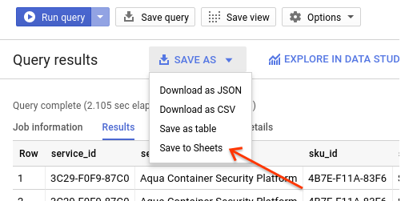

Examine the data
Determining whether the data are correct requires knowledge about what the application is metering. For applications that simply meter based on running time, sum the usage_amount column over the exported time range and ensure that the total amount of reported usage aligns with the reporting time range. Be aware of any scaling factor that the application should apply to usage reports. For example, if the application is priced based on node-hours, and the deployment has 3 nodes, a usage_amount sum should be three times greater than its time range.

For other types of usage, such as count or data processed, ensure that exported usage matches the usage that you generated in the previous step.

